WEEK-5
REACT
React Lab Initialization
The objective of this hands-on lab was to understand the fundamentals of Single-Page Applications (SPAs) and React, including the Virtual DOM and the differences between SPAs and MPAs.
The practical requirements were to:
- Set up a local React development environment using Node.js and NPM.
- Initialize a new React application named myfirstreact using the create-react-app tool.
- Modify the default application code in App.js to render a specific heading: "welcome to the first session of React".
- Run the application and verify the output in a web browser on localhost:3000.
To complete the lab requirements using IntelliJ IDEA, the following steps were executed:
- Project Creation: Instead of running terminal commands manually, the built-in New Project wizard in IntelliJ IDEA was utilized. A new project named myfirstreact was created, explicitly configuring the React CLI dropdown to use create-react-app to match the lab's exact environment requirements.
- Code Modification: Located and opened the App.js file within the generated src directory. The default boilerplate code was completely removed and replaced with a clean functional component to display the requested heading
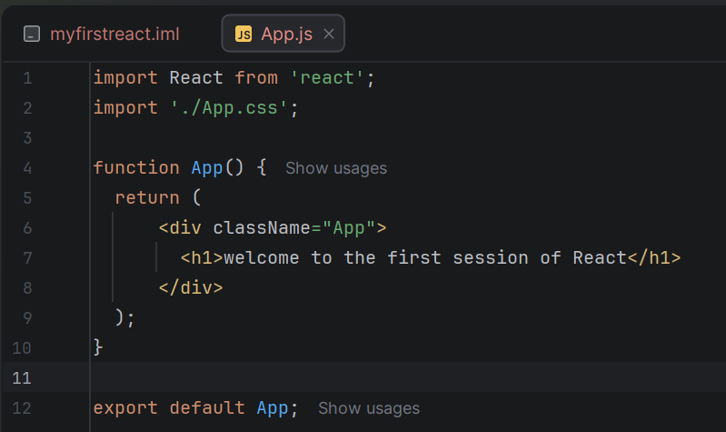
OUTPUT:
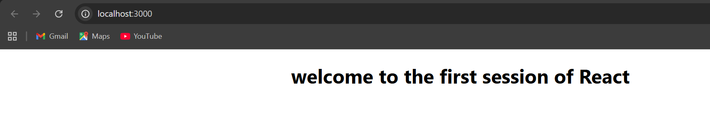

Student Management Portal Components
The objective of this hands-on lab was to understand React components, specifically focusing on the differences between functional and class components, the purpose of the render() function, and how to structure and invoke multiple components within a single application.
The practical requirements were to:
- Create a new React application named StudentApp.
- Create three distinct class components: Home, About, and Contact.
- Configure the Home component to display: "Welcome to the Home page of Student Management Portal".
- Configure the About component to display: "Welcome to the About page of the Student Management Portal".
- Configure the Contact component to display: "Welcome to the Contact page of the Student Management Portal".
- Invoke (render) all three components simultaneously within the main application view.
- • Project Initialization: Created a new React project named StudentApp using IntelliJ's New Project wizard, utilizing the create-react-app CLI configuration for the initial setup.
- • Folder Structure Organization: Created a dedicated Components directory inside the src folder to follow standard React project organization practices.
- • Component Creation: Authored three separate JavaScript files (Home.js, About.js, and Contact.js) within the Components directory. Each file was implemented as a React Class Component, utilizing the render() method to return the specific required text wrapped in <h2> tags.
- • Component Invocation: Modified the main App.js file to import the newly created Home, About, and Contact components. Their respective JSX tags (<Home/>, <About/>, and <Contact/>) were added inside the main App component's return block so they would render together.
- • Deployment & Verification: Launched the development server via the integrated IntelliJ terminal using the npm start command. Verified that the browser successfully opened http://localhost:3000 and displayed all three component messages on the page.
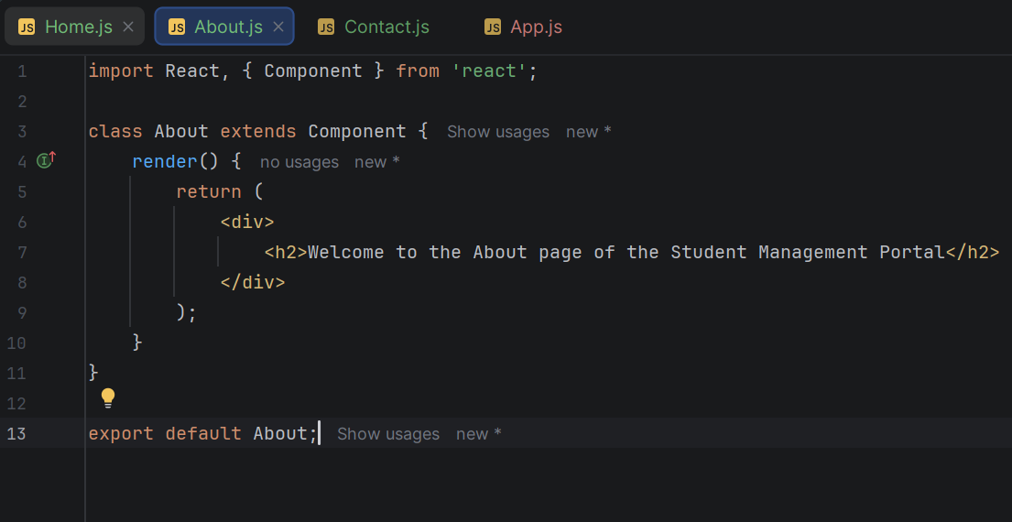
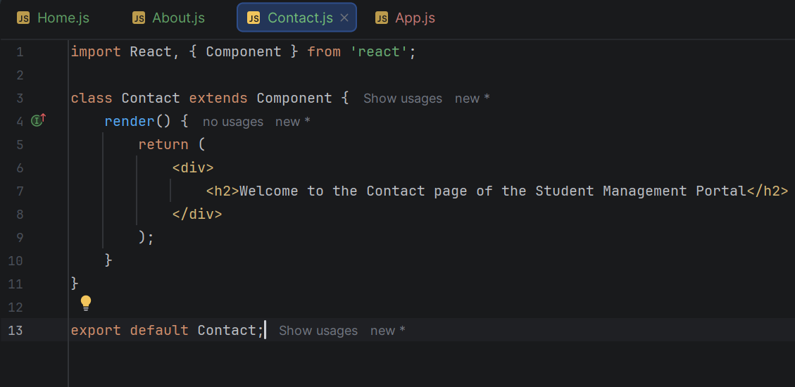
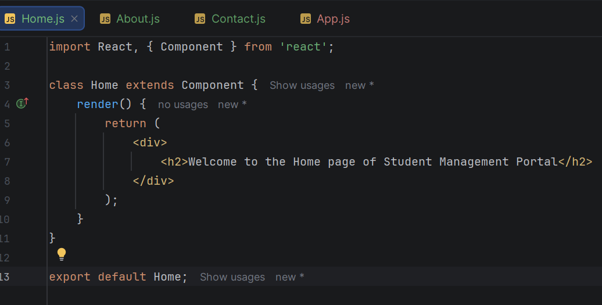
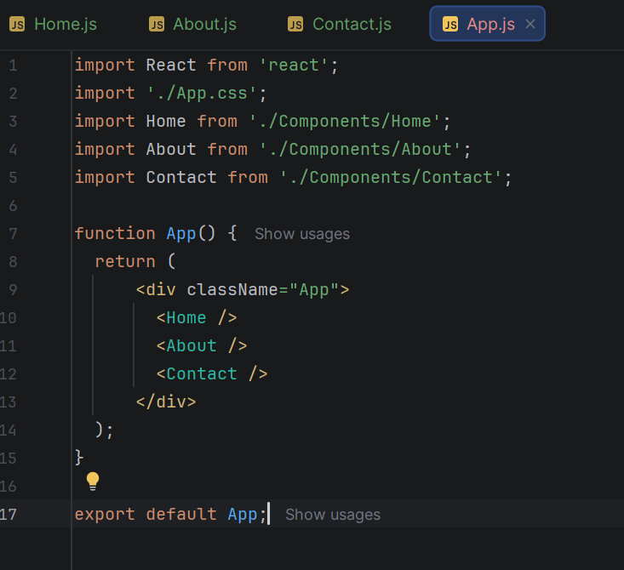
OUTPUT:
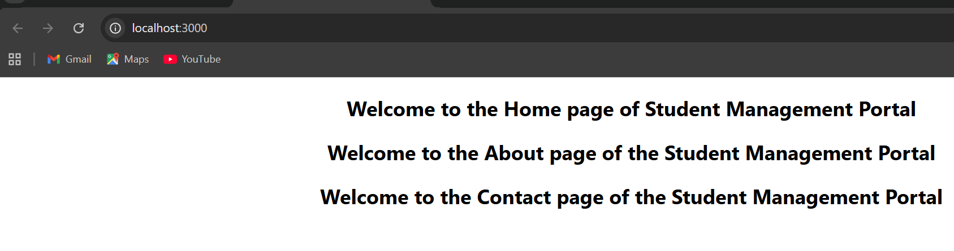

Student Score Calculator App
The objective of this hands-on lab was to explore React functional components, understand how they differ from class components, learn how to pass data using properties (props), and apply external CSS styling to React elements.
The practical requirements were to:
- Create a new React application named scorecalculatorapp.
- Create a functional component named CalculateScore that accepts four parameters (props): Name, School, Total, and Goal.
- Calculate the average score of the student based on the Total and Goal values provided.
- Create a custom stylesheet (mystyle.css) inside a Stylesheets folder to style the component visually.
- Invoke the CalculateScore component inside the main App.js file, passing in the required data, and run the application to view the output on localhost:3000
To complete the lab requirements using IntelliJ IDEA, the following steps were executed:
- Project Initialization: Created a new React project named scorecalculatorapp using the IntelliJ New Project wizard, specifically utilizing the create-react-app CLI layout to match the lab environment.
- Folder & Style Setup: Created two new directories within the src folder: Components and Stylesheets. Added a mystyle.css file to the Stylesheets folder, defining classes (like .score-card) to give the output a clean, structured appearance with borders and centered text.
- Functional Component Implementation: Created CalculateScore.js in the Components folder. This file was written as a pure functional component that destructures { Name, School, Total, Goal } from its props. It calculates the average by dividing Total by Goal and returns a JSX structure displaying the student's details and their calculated average score, styled using the imported CSS.
- Component Invocation: Modified App.js to import the CalculateScore component. Invoked the component inside the main App return block and passed sample data (e.g., Name="John Doe", Total={450}) into the component as props.
- Deployment & Verification: Executed the npm start command in the IntelliJ integrated terminal. The development server successfully launched, displaying the styled score card and the correctly calculated average in the web browser at `

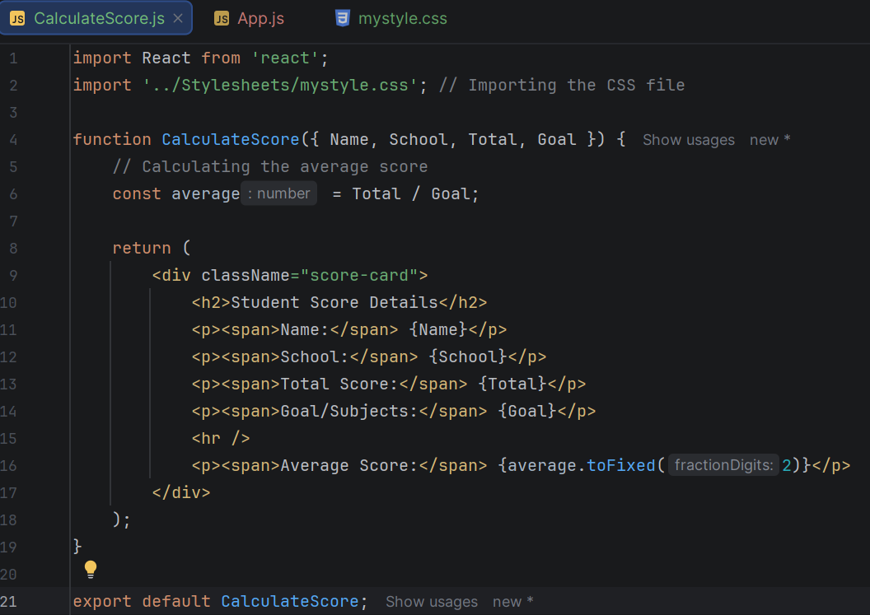
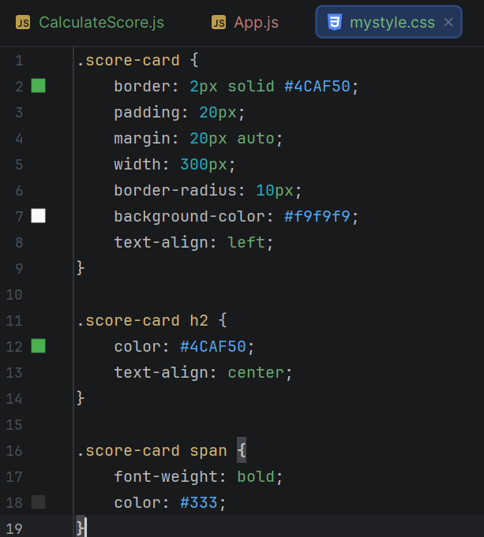
OUTPUT:
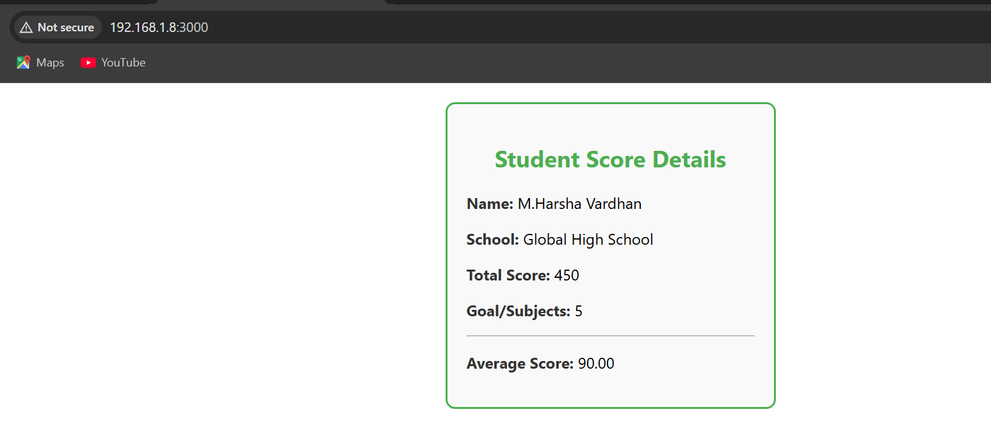
React Component Lifecycle & Fetch API
The primary objective of this hands-on lab was to understand the React component lifecycle, specifically focusing on how to execute code at specific phases of a component's existence using lifecycle hook methods.
The practical requirements were to:
- Create a new React application named blogapp.
- Create a data model class named Post containing id, title, and body properties.
- Create a class-based component named Posts and initialize its state with an empty array of posts inside the constructor.
- Implement a custom loadPosts() method that uses the Fetch API to retrieve post data from a placeholder URL ([jsonplaceholder.typicode.com/posts](https://jsonplaceholder.typicode.com/posts)) and update the component's state.
- Implement the componentDidMount() lifecycle hook to trigger the loadPosts() fetch operation as soon as the component loads.
- Implement the componentDidCatch() lifecycle hook to catch and display any rendering errors as alert messages.
- Implement the render() method to display the fetched data, formatting titles as headings and post content as paragraphs.
- Invoke the Posts component inside the main App.js file
• Project Initialization: Created a new React project named blogapp using the create-react-app template within IntelliJ IDEA.
• Data Model Creation: Authored a standalone Post.js file that defines a standard JavaScript class with a constructor to structure the incoming id, title, and body data.
• Component Implementation (Posts.js):
- State Setup: Created a React class component, establishing this.state = { posts: [] } in the constructor.
- Data Fetching: Implemented loadPosts() to asynchronously fetch data from the provided API, map the resulting JSON array into instances of the Post class, and update the state using this.setState().
- Lifecycle Hooks: Added componentDidMount() to automatically call this.loadPosts() exactly once when the component mounts. Added componentDidCatch() containing an alert() to capture and report unexpected errors gracefully.
- Rendering UI: Wrote the render() method to iterate through this.state.posts using the .map() function, rendering an <h3> heading for each title and a <p> tag for each body.
• Integration & Deployment: Modified App.js to import and render the <Posts/> component. Launched the application via the built-in terminal using npm start to verify that the API data was successfully fetched and displayed on localhost:3000.
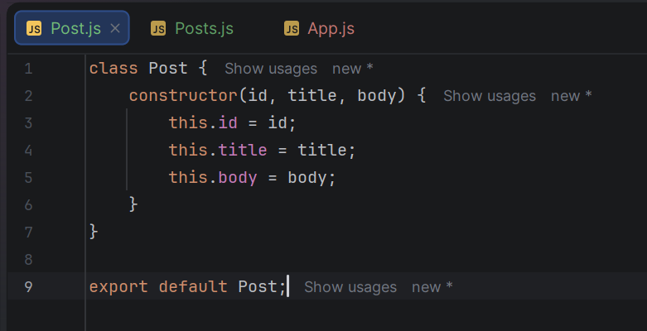

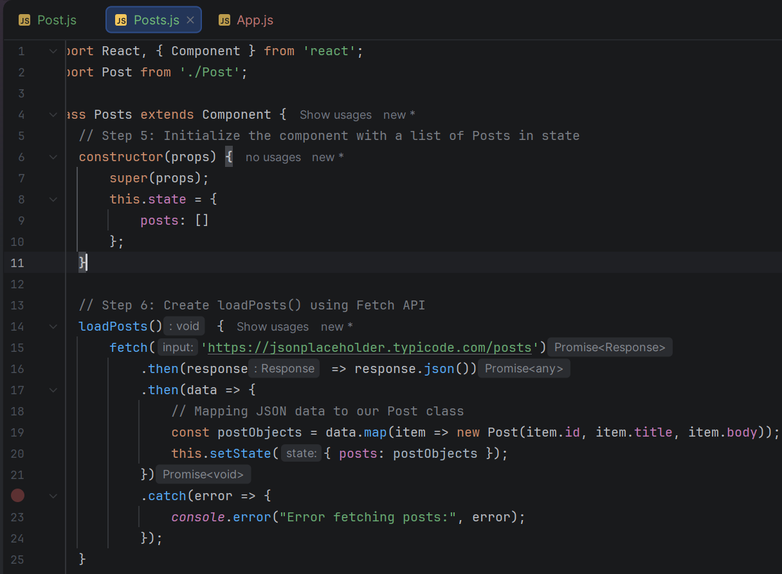
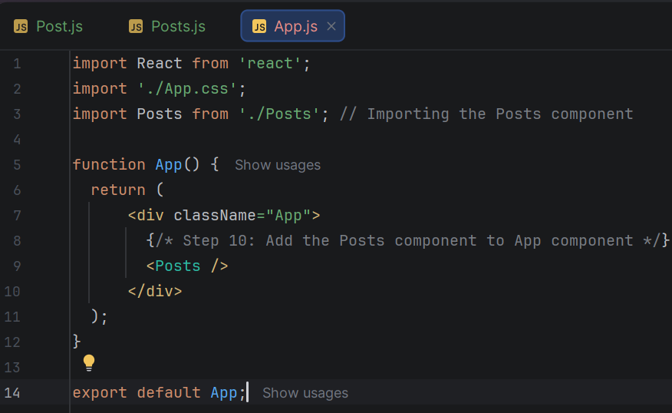
OUTPUT:
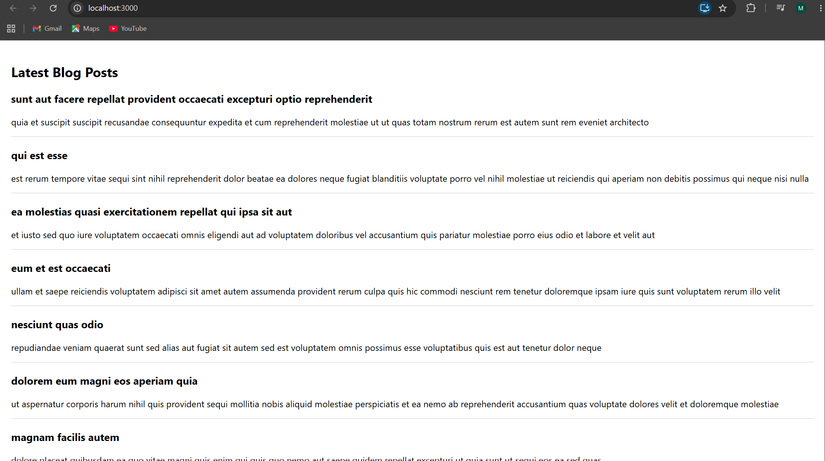

React Router SPA for Trainers Portal
The objective of this hands-on lab was to understand the need for and benefits of React Router in building Single-Page Applications (SPAs). This included identifying router components, defining routes, and passing parameters via the URL.
The practical requirements for the Cognizant Academy portal were to:
- Create a new React application named TrainersApp.
- Create a data model (Trainer class) containing specific properties: TrainerId, Name, Email, Phone, Technology, and Skills.
- Generate a mock data file (TrainersMock.js) populated with sample Trainer instances.
- Install and configure the react-router-dom library.
- Create three main UI components:
  - Home: A landing page with a welcome message.
  - TrainersList: A page displaying a list of trainers, where each name acts as a hyperlink.
  - TrainerDetail: A page that retrieves the trainer's ID from the URL parameters using the useParams hook to display their specific details.
- Configure the main App.js component to handle routing for the /, /trainers, and /trainers/:id paths, alongside a persistent navigation menu.

To complete the lab requirements using IntelliJ IDEA, the following steps were executed:
- Project Initialization & Dependencies: Created the React project via IntelliJ's project wizard using create-react-app. Opened the built-in terminal and executed npm install react-router-dom to add routing capabilities to the project.
- Data Modeling: Authored trainer.js to define the class structure and TrainersMock.js to instantiate an array of mock trainer data to simulate a backend response.
- Component Development:
  - Created Home.js for the default landing view.
  - Created TrainersList.js, which imports the mock data and uses the .map() function alongside the React Router <Link> component to generate dynamic URLs for each trainer (e.g., /trainers/1).
  - Created TrainerDetails.js, utilizing the useParams hook to capture the URL parameter, match it against the mock data array, and render the specific data fields for the selected trainer.
- Routing Configuration: Restructured App.js by wrapping the application in a BrowserRouter. Added a <nav> bar with <Link> tags for top-level navigation, and defined <Routes> to map the specific URL paths (/, /trainers, and /trainers/:id) to their respective components.
- Deployment & Verification: Ran the application using the npm start command. Verified in the browser (localhost:3000) that the navigation menu dynamically swapped the components without triggering a full page reload, successfully demonstrating SPA routing.
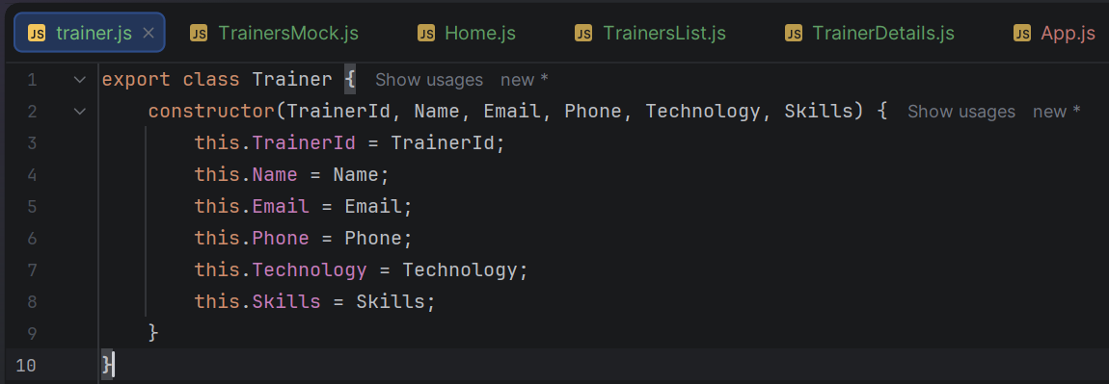
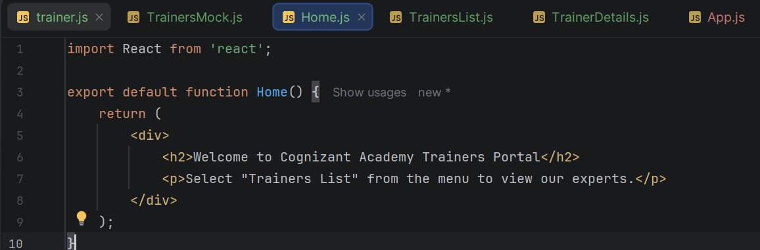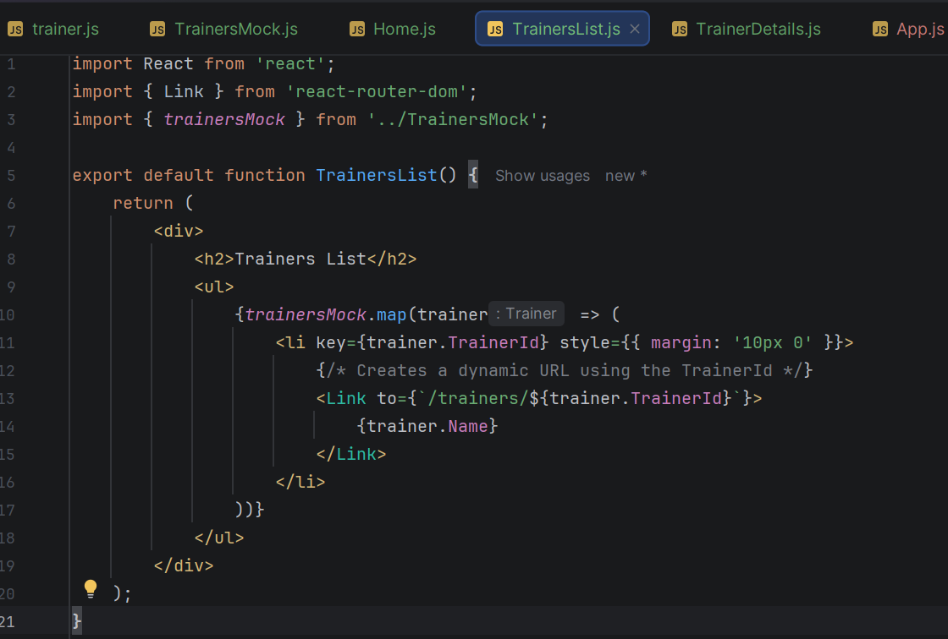

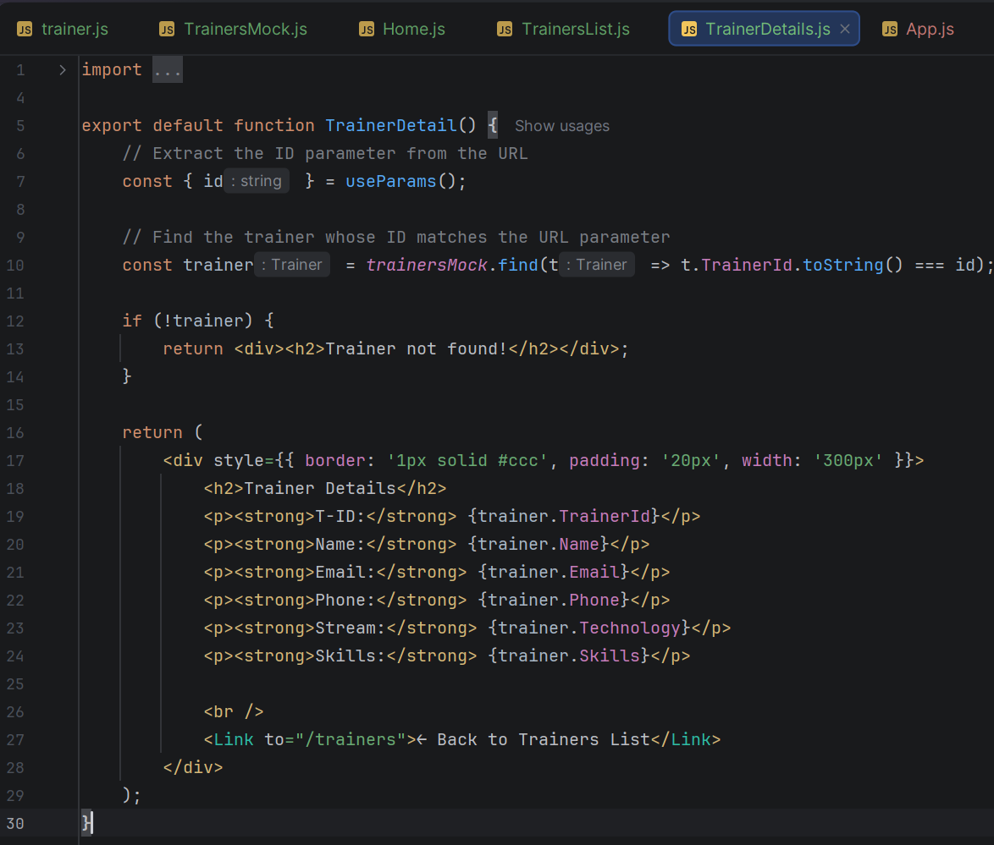
OUTPUT:
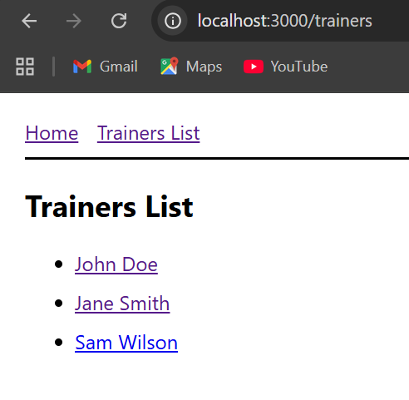

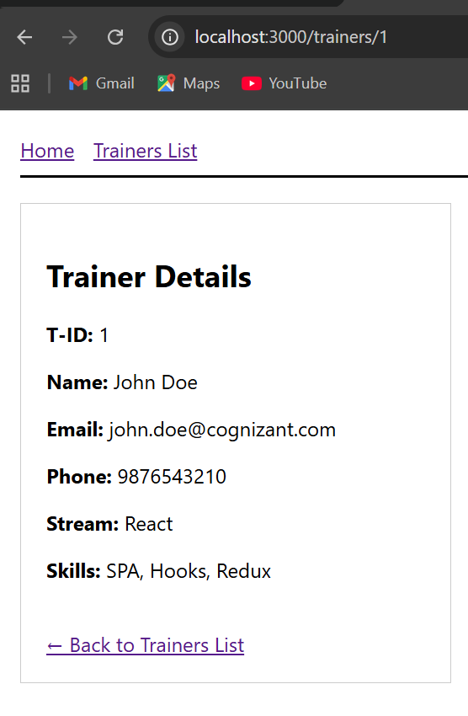

s

